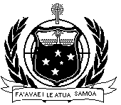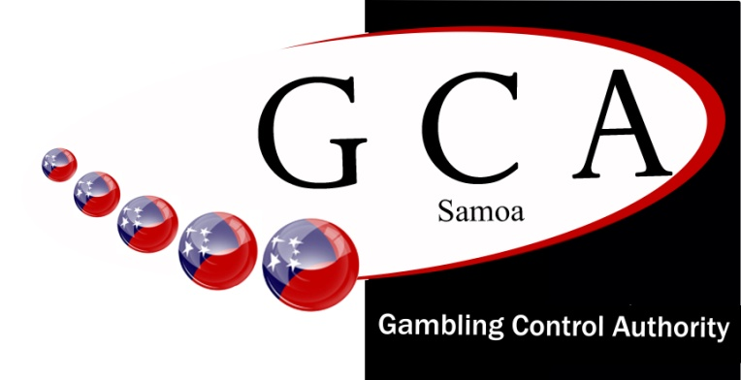

**Gambling Control Authority**

Phone: +685 26512/ 727 1270

Fax +685 26965

Email: *ceo@gca.gov.ws*

Email: *info@gca.gov.ws*

*www.gca.gov.ws*

PO Box 3075

Apia, SAMOA

Samoa

GOVERNMENT OF SAMOA

**APPLICATION FORM: SPORTS FUNDING**

***ALL QUESTIONS MUST BE ANSWERED TO QUALIFY FOR CONSIDERATION***

***Each applications is referred to the GCA Board and no guarantee is given that the application will be granted or renewed, Applicants must first apply for scholarships and sponsors from Government and private sources before approaching GCA. Written applications to be delivered to GCA office at least 4 weeks before funds needed.***

|  |  |
| --- | --- |
| *Name of Sports Organization* |  |
| *Name of Contact Person*  *Address & mobile phone number*  *Email address* |  |
| *Purely Non For Profit (MCIL Registered)*  *Constitution and Bylaws* |  |
| *Copy Current Audited Account (latest)* |  |
| *Event budget and expenses forecast* |  |
| *Other funding sorted* |  |
| *Organization contribution to costs* |  |
| *Number of members to benefit from event* |  |
| *Other related information* |  |

***GCA: Education 001/2018***